We will be performing analysis on the UBER data-set in HADOOP using ‘PIG’ scripting data language .
Pig’s simple SQL-like scripting language is called Pig Latin, and appeals to developers already familiar with scripting languages and SQL.
Pig is complete, so you can do all required data manipulations in Apache Hadoop with Pig. Through the User Defined Functions(UDF) facility in Pig, Pig can invoke code in many languages like JRuby, Jython and Java. You can also embed Pig scripts in other languages. The result is that you can use Pig as a component to build larger and more complex applications that tackle real business problems.
Pig works with data from many sources, including structured and unstructured data, and store the results into the Hadoop Data File System.
Pig scripts are translated into a series of MapReduce jobs that are run on the Apache Hadoop cluster.
We will be performing analysis on the UBER data-set in HADOOP using ‘PIG’ scripting data language .
Pig’s simple SQL-like scripting language is called Pig Latin, and appeals to developers already familiar with scripting languages and SQL.
PROBLEM: FIND THE BASEMENT WHICH HAS MORE NO OF TRIPS:
You can download the dataset from here:

Data set that we have entered :
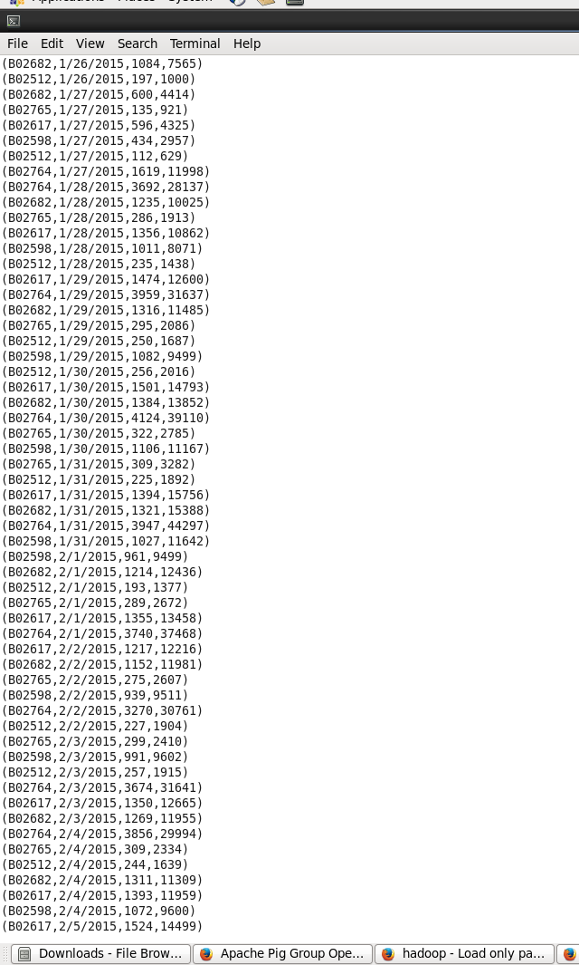

MOVING DATA SET TO THE HDFS FOR FURTHER PROCESSING OF DATA.
MOVING OF DATA SET CAN BE DONE USING THE COMMAND:

hadoop fs -mkdir /user/UBER
hadoop fs -put /uber /user/UBER

CHECK WHETHER THE DATA IS MOVED BY USING THE COMMAND:
hadoop fs -put /uber /user/UBER

START THE PIG ENVIORNMENT USING THE PIG COMMAND:
pig

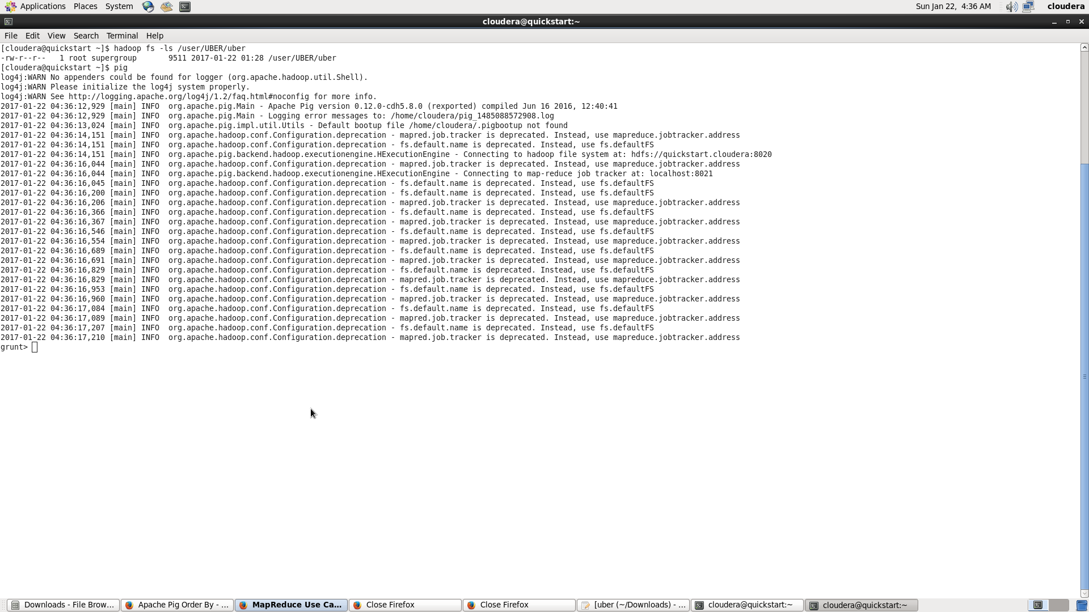

MAKING THE TUPLE FROM THE DATA SET HAVING ‘ ,’ AS THE DELIMITER USING THE PIGSTORAGE COMMAND:
THE COMMAND USED IS :
uber_data_set = load '/user/UBER/uber' using PigStorage(',') as ( dispatching_no : chararray,data_value :chararray ,no_of_active :int ,no_of_trips :int );

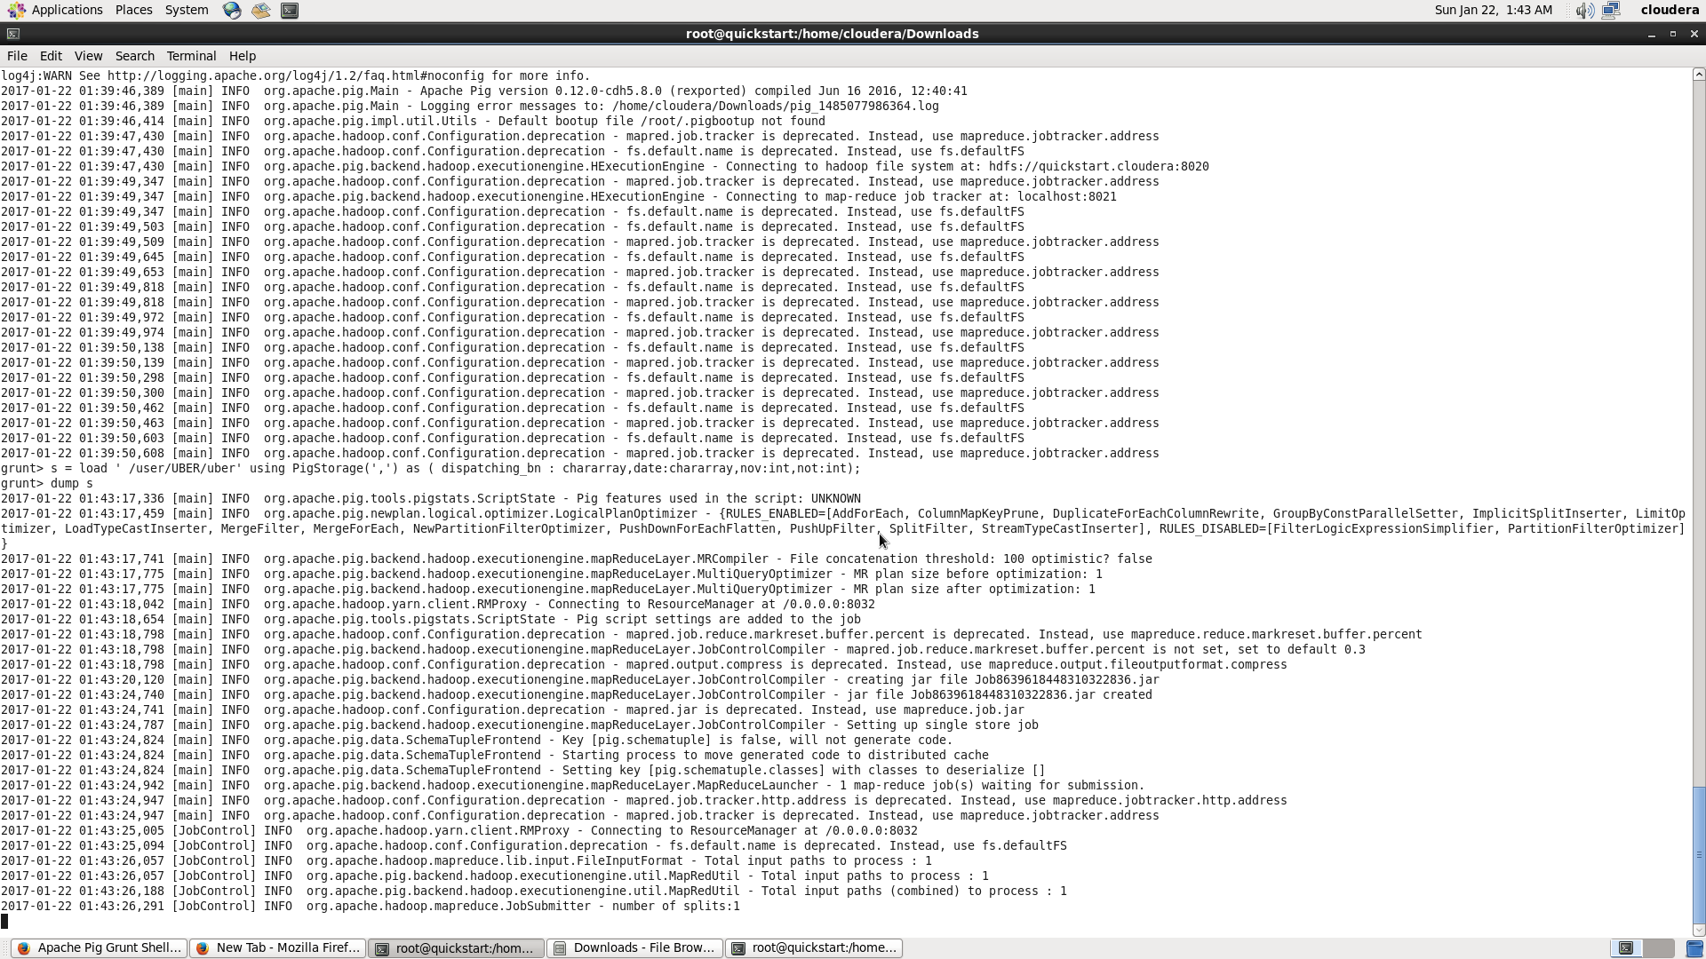

NOW BY USING THE COMMAND DUMP WE CAN CHECK THE DATA THAT IS LOADED INTO THE VARIABLE.
DUMP uber_data_set

NOW GROUP THE BATCH COLUMN SO THAT WE CAN COUNT THE NUMBER OF VEHICLES THAT ARE ON THAT TRIP
USE THE COMMAND :
inter_uber_data = group uber_data_set by dispatching_no;
CHECK THE DATA THAT IS GROUPED BY USING THE DUMP COMMAND:
Dump inter_uber_data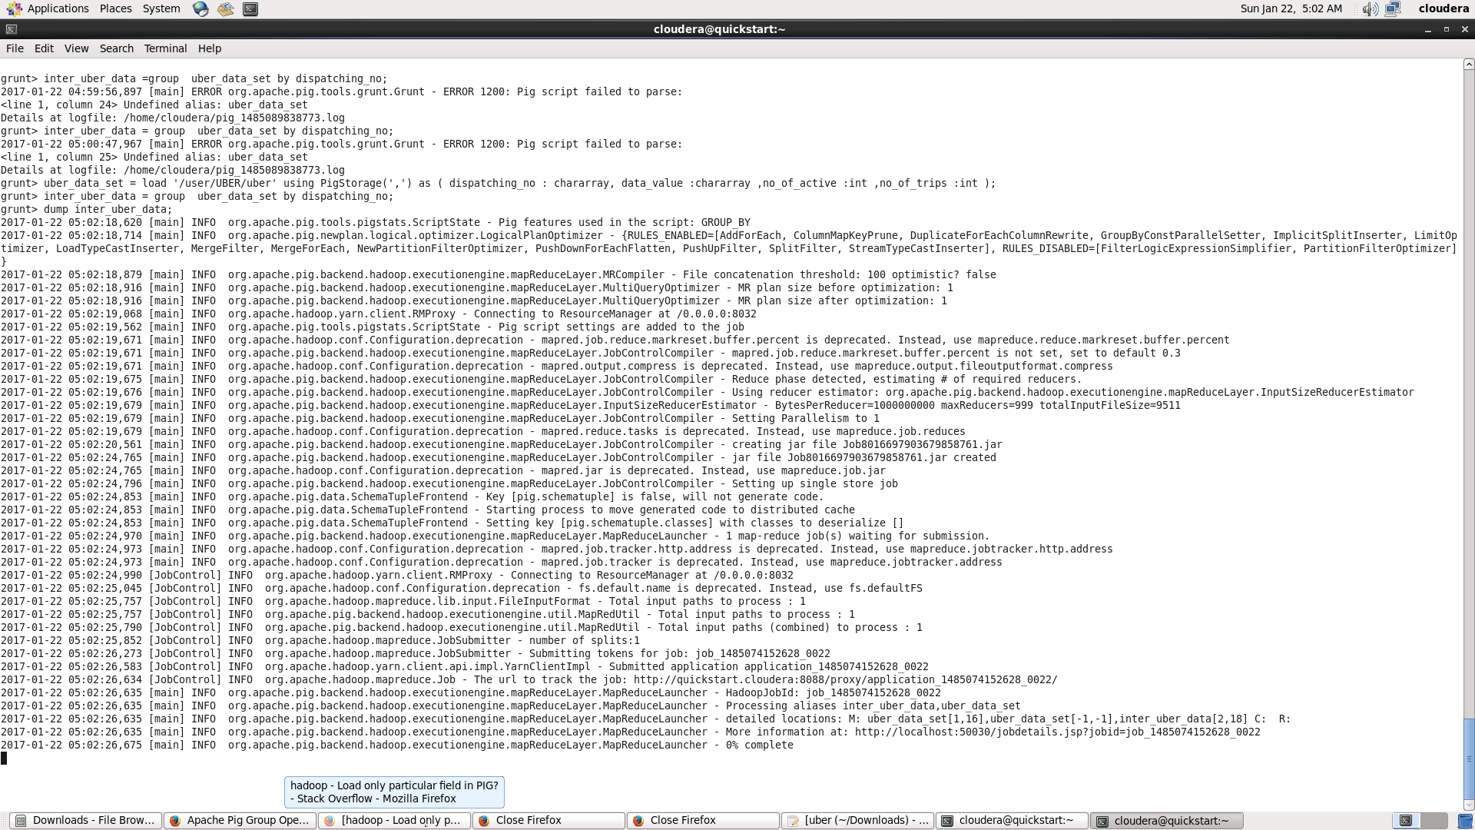

NOW GENERATE THE DATA SET SUM USING THE COMMAND:
grouped_data_set = foreach inter_uber_data generate group,SUM(uber_data_set.no_of_trips);
dump grouped_data_set

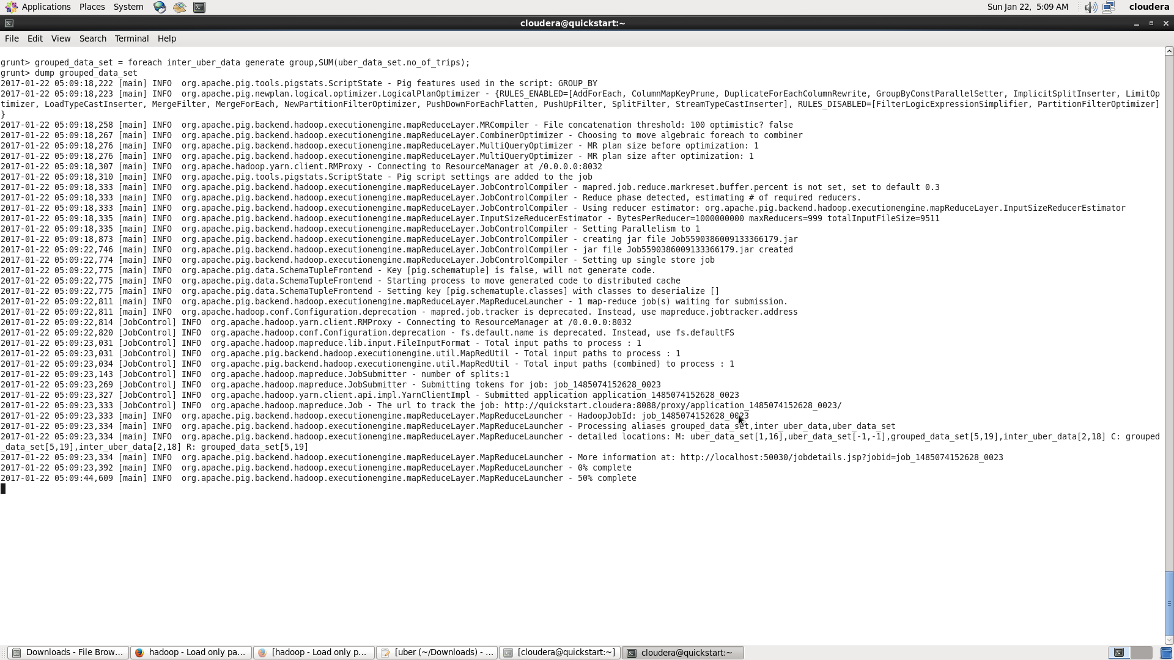

NOW DUMP THE DATA THAT HAS GROUPED :

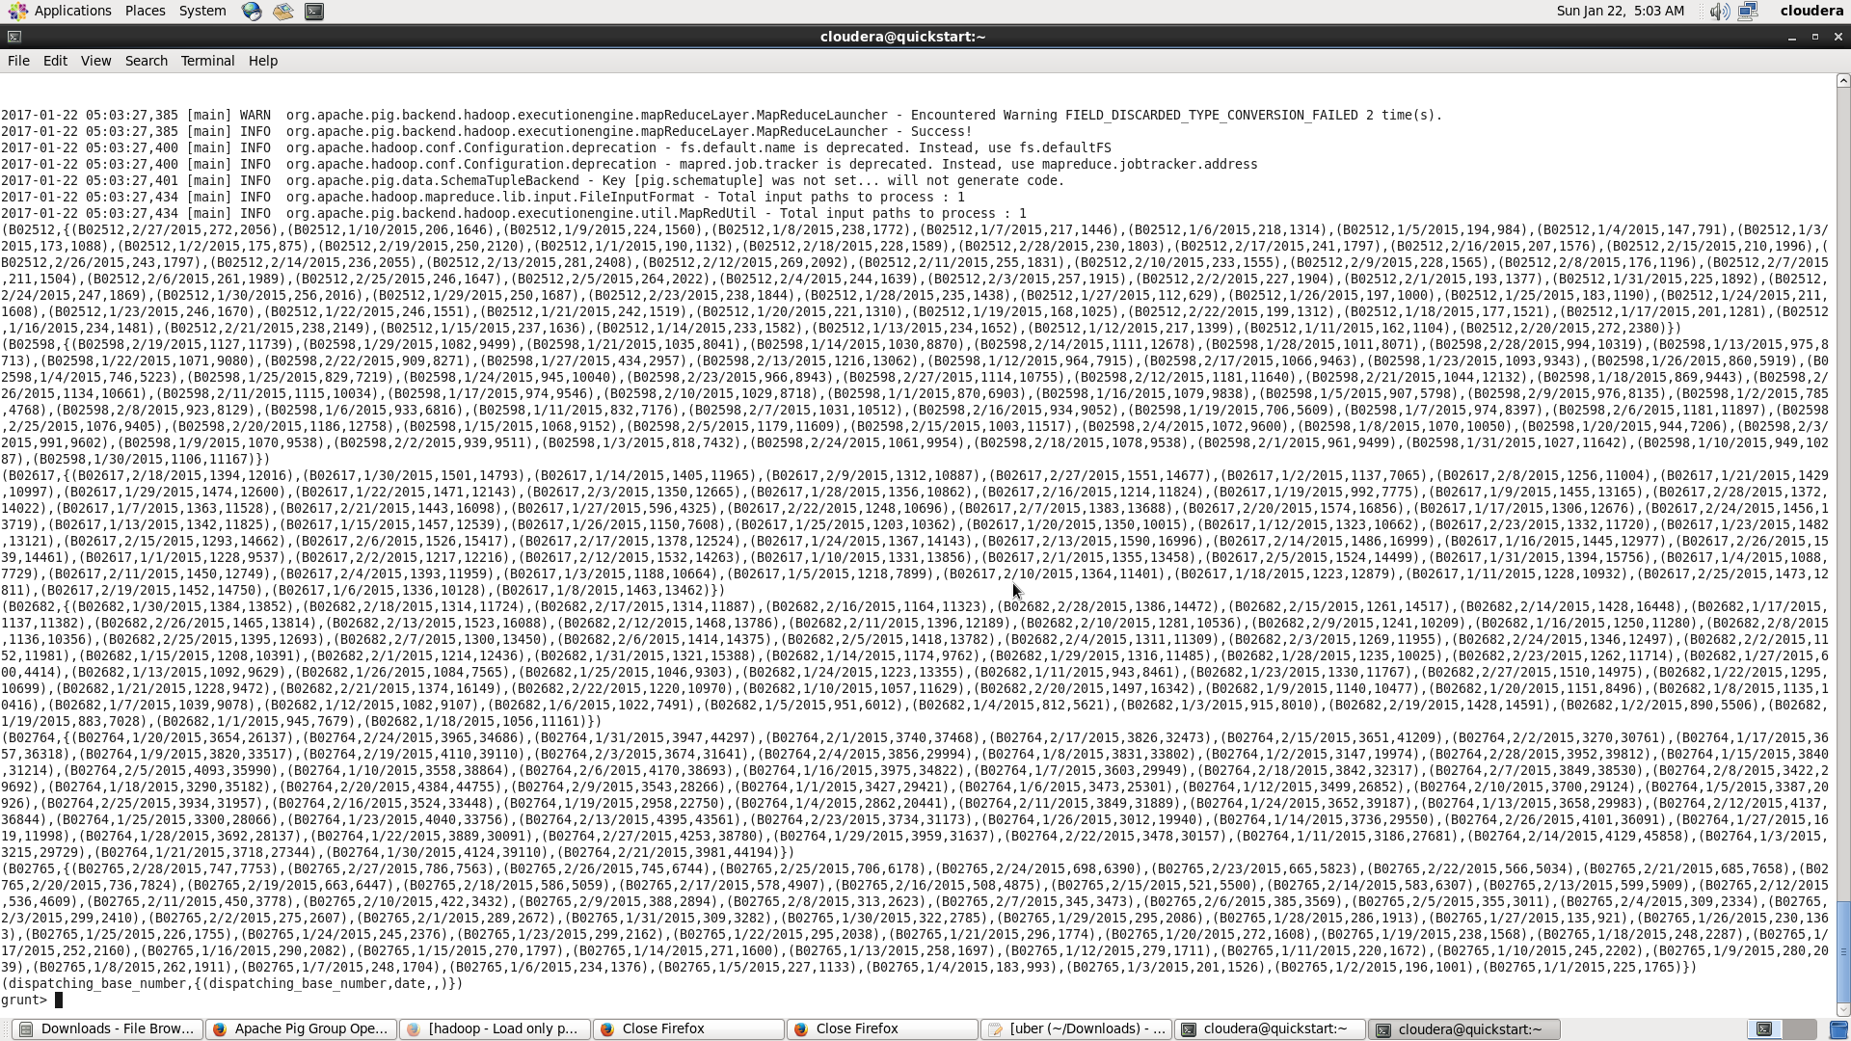

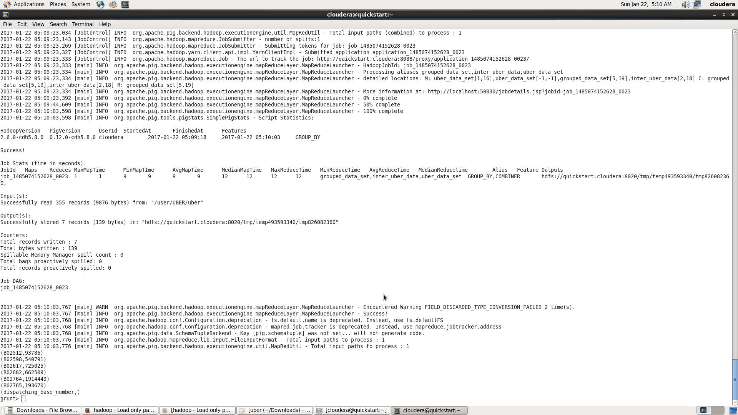

THE DATASET FOR SORTING:
ordered_data_set = order grouped_data_set by $1 desc;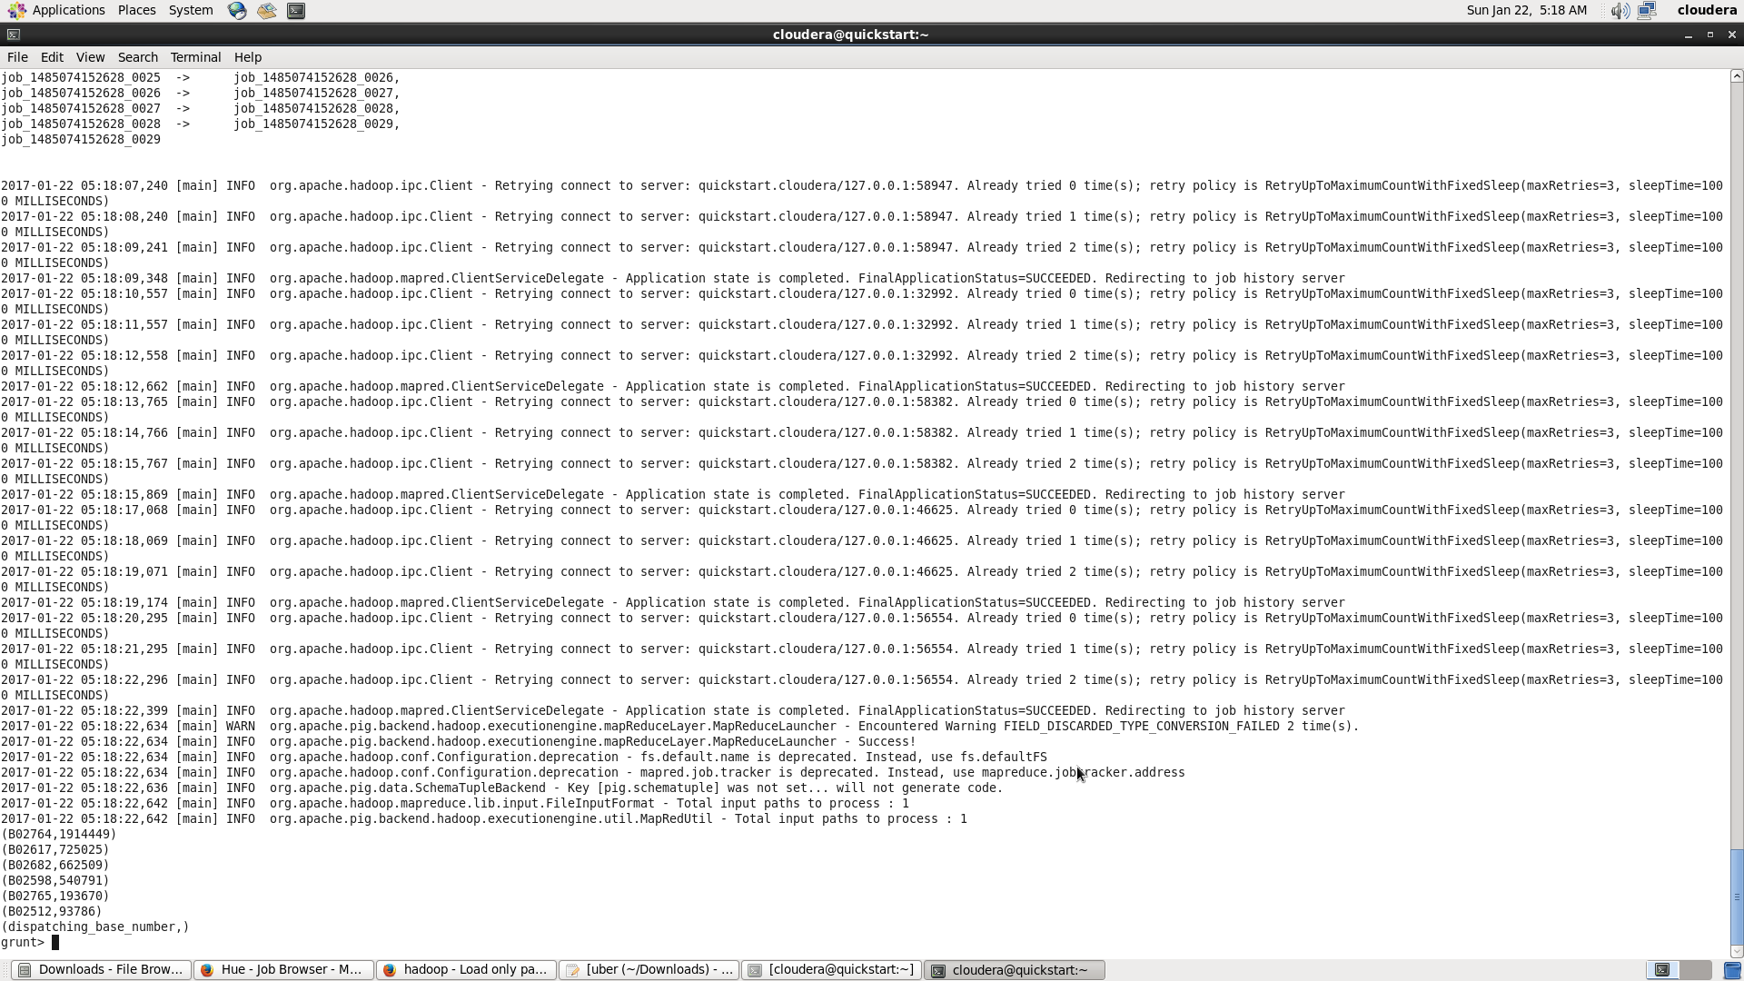

LIMIT THE DATA SET BY 2 BY USING THE LIMIT COMMAND:
limited_data_set = limit by 2
dump limited_data_set
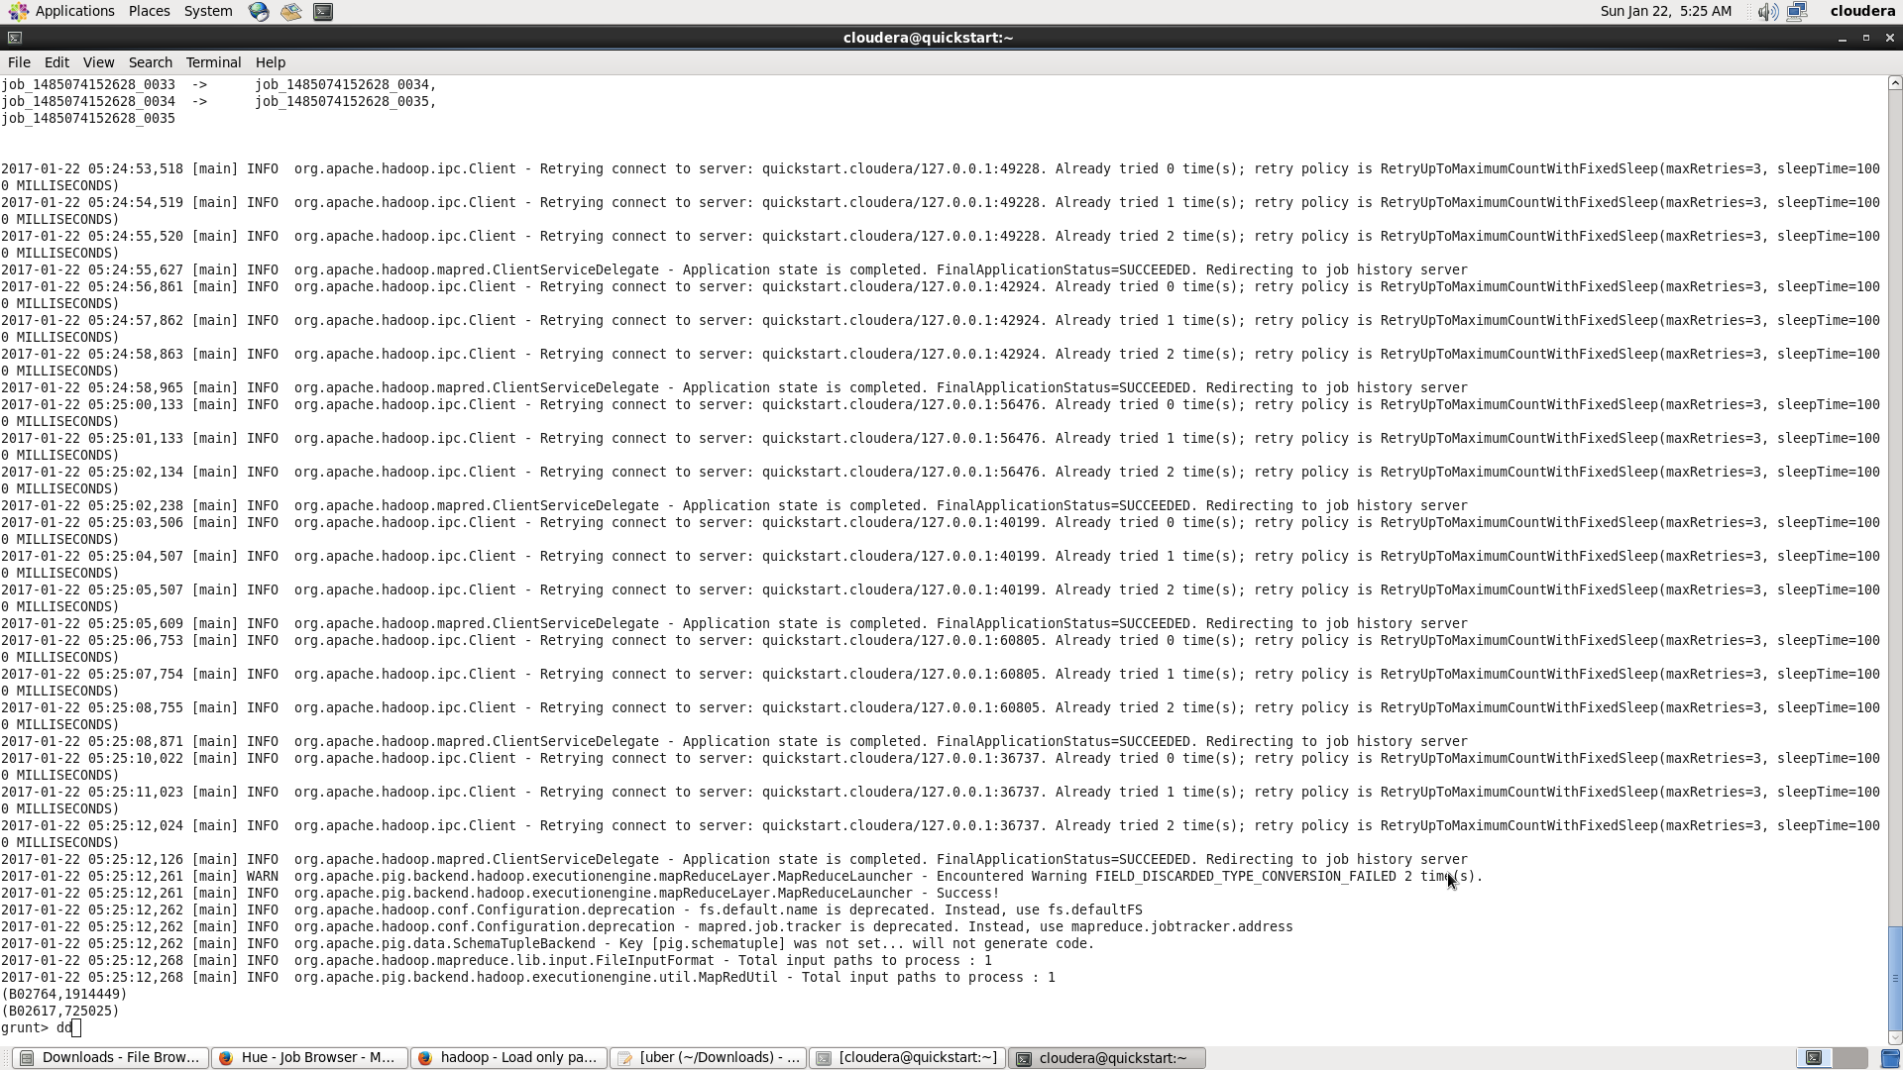

STORE THE DATASET USING THE STORE COMMAND IN PIG:
store limited_data_set into '/user/UBER/port'using PigStorage(',');
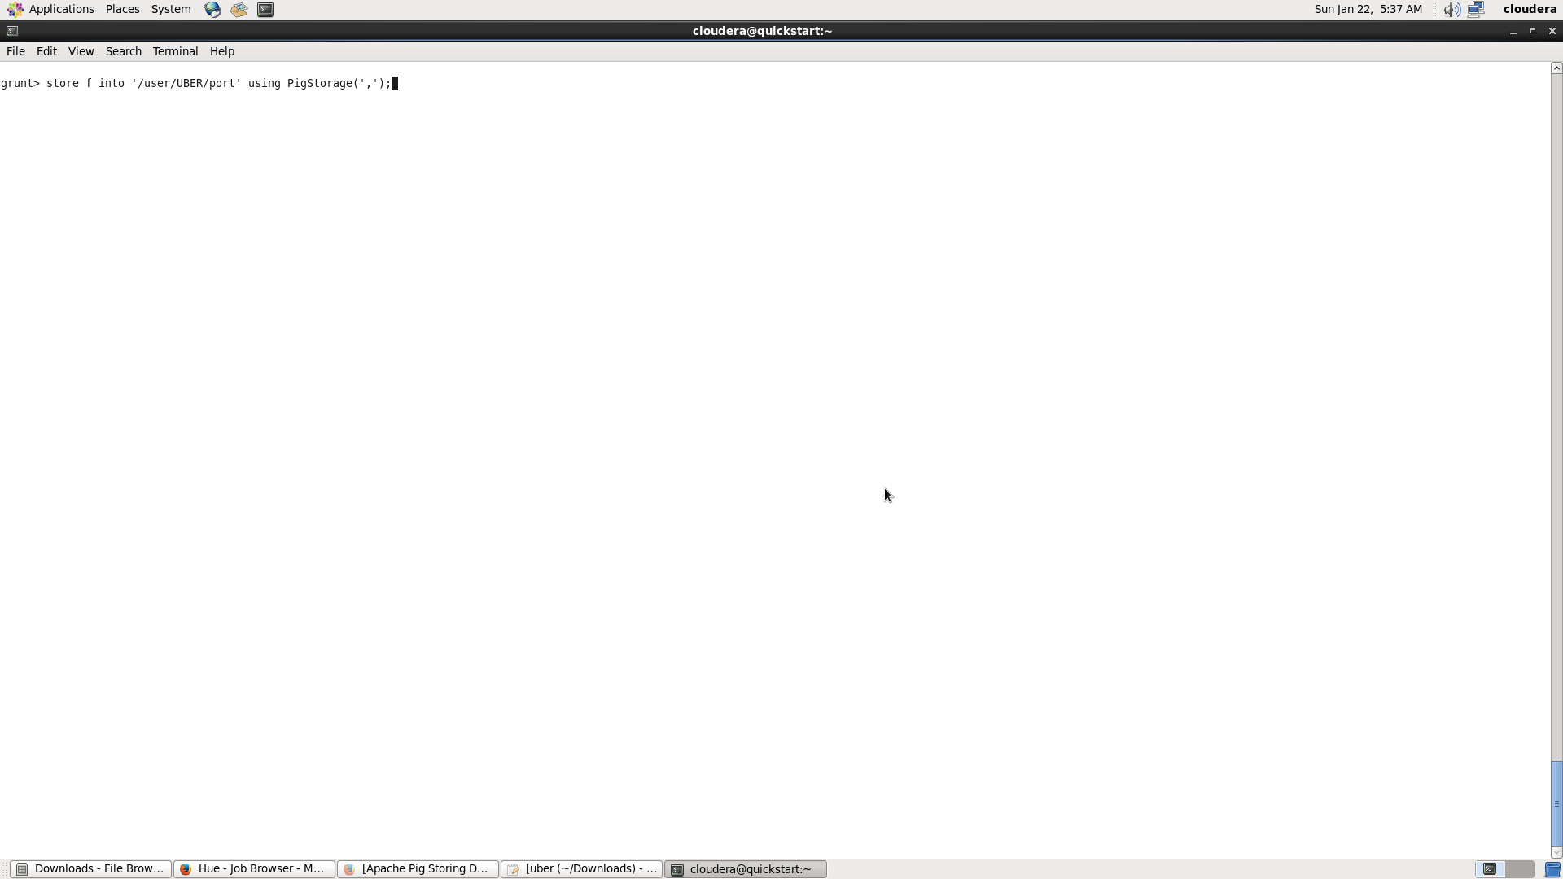
THE DATA SETS ARE FORMED IN PARTM FILES.

